Professional Development Sessions: Introduction on Templates
and
Revisit Templates – Post Implementation
Speaker: Mrs. Debora Liberi, CEEMS District Coordinator
Dates: 06/21/2016 and 7/26/2016
Times: 1:00 pm – 2:30 pm and 10:00 am – 11:00 am
Venue: University of Cincinnati, Zimmer Hall, Room 414
Prepared by:
Matthew Brunner, Saints Peter and Paul School, California, Kentucky
RET Project #3: Enhancing Decision Making Emulating Human Reasoning

These sessions were given by Mrs. Debora Liberi, CEEMS District Coordinator on Tuesday, June 21, 2016 and July 26th, 2016, in Zimmer Hall, room 414.

Debbie Liberi currently serves as the District Coordinator for the CEEMS grant at UC and as Coordinator for the RET Program. She earned BA in Biology at Wittenberg University and a Masters in Secondary Educations from UC, as well as, a Masters in Library and Information Science from Kent State University. She was a middle school science teacher and high school librarian for 35 years with CPS. From 2000-2010, Debbie was a National Board Certified Teacher in Early Adolescence Science. She also served as a lead teacher in various mentoring roles for CPS. In addition, Debbie has served as an adjunct faculty in the Teachers College at UC and at Xavier University.

Teachers were asked to give a thumbs up or thumbs down if they were comfortable using units. Most thumbs were down or sideways. Teachers worked on a pre-quiz on pencil and paper. The Templates are the structures used to build the Unit based on CBL. The Templates for the Unit and Activities are available on the Wiki and in the binders. Teachers were given hand-outs which described templates and how they are used with Challenge Based Learning. Teachers were asked to read and highlight anything that they felt was confusing or needed clarification.

Figure 1: Highlighting Questions Figure 2: Mrs. Liberi Showing The Road Map
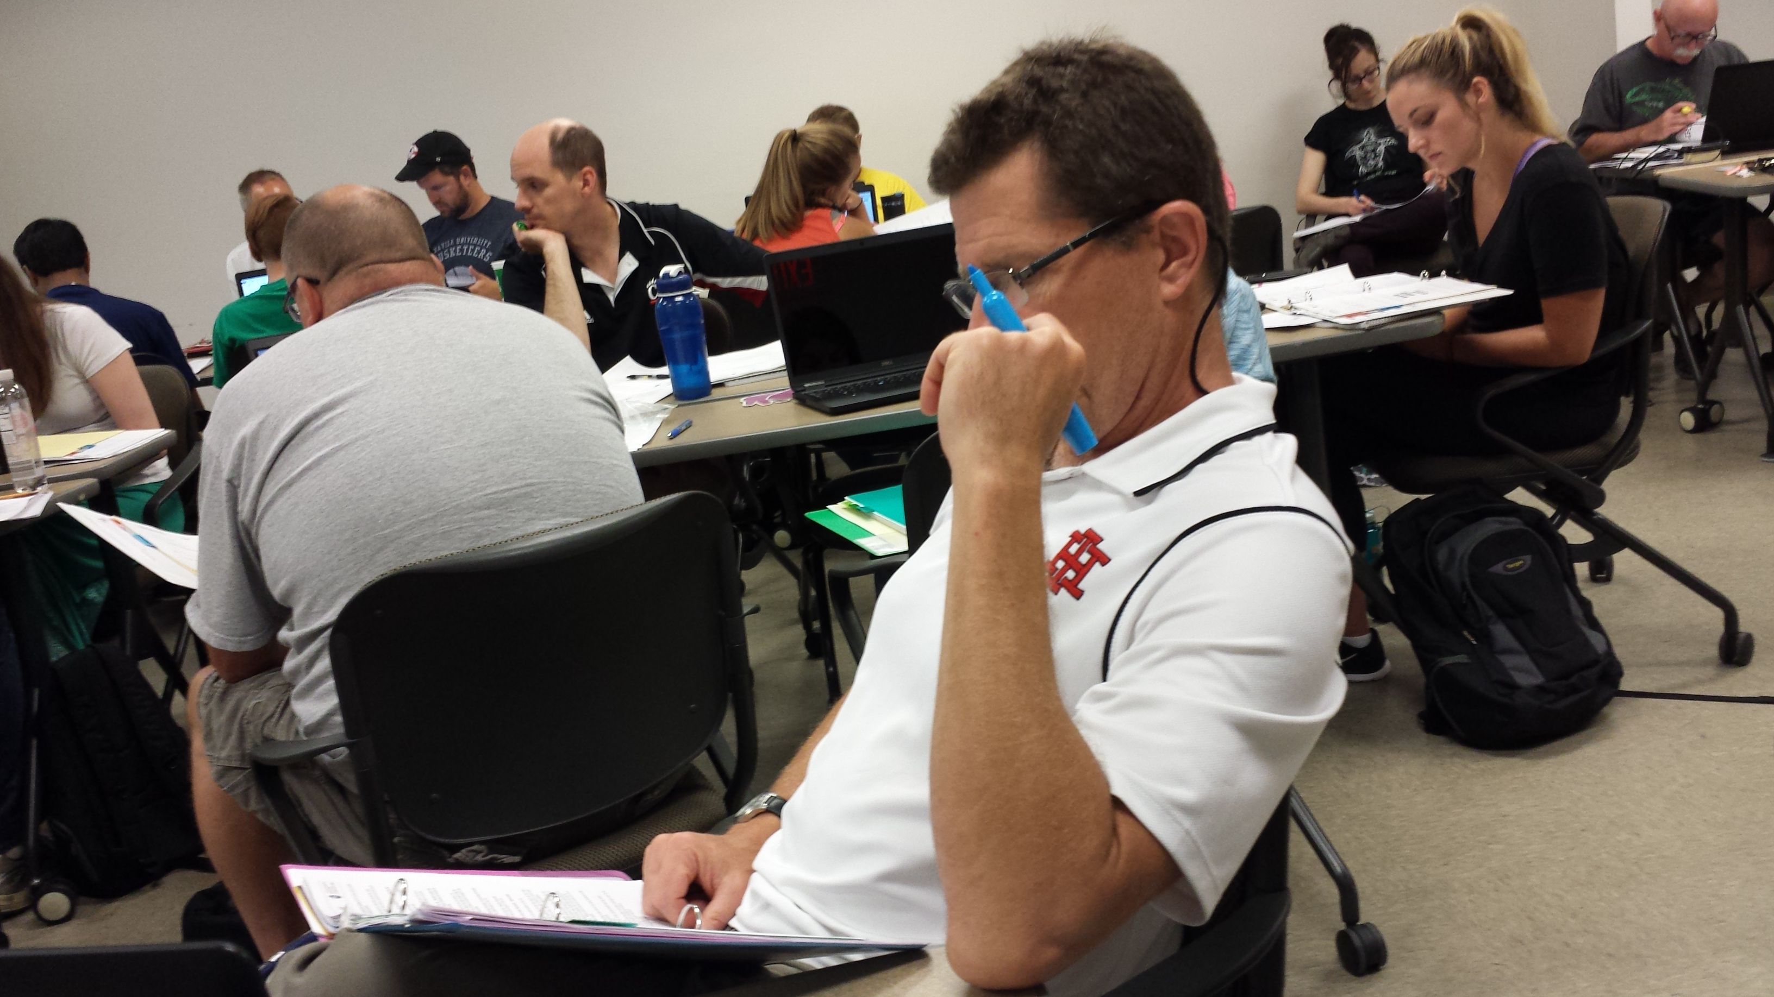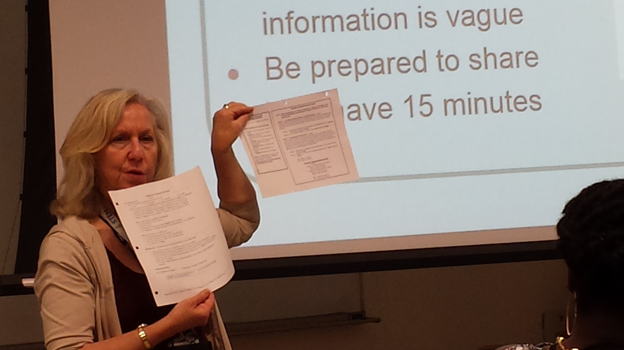

Mrs. Liberi took questions about anything that was highlighted. After all questions were answered she showed teachers the road map for the unit. Mrs. Liberi also shared was a glossary and sample lesson format which supports completion of the templates. The unit for challenge based learning consists of two lessons, each lesson has two activities. The length of the lessons is not set in stone, it can be several days or one day.

There is a hierarchy in the unit template. Start with the unit template, because that is where everything else flows. The unit template for CEEMS is a unit that involves a challenge; the unit is centered on the challenge. Students will be assessed while using the EDP cycle. It won’t look the same as the rest of your unit. A lesson can last several days and be over several concepts. Activities are standalone entities and can be used with or without the challenge.

Challenge based learning (CBL) and the Engineering Design Process (EDP) hold the students attention and keep them accountable. All CBL and EDP units must be based on the content standards. Mrs. Liberi asked teachers to think of hooks for their units. Having guest speakers, dressing up, playing games, demonstrations and videos were mentioned by teachers.

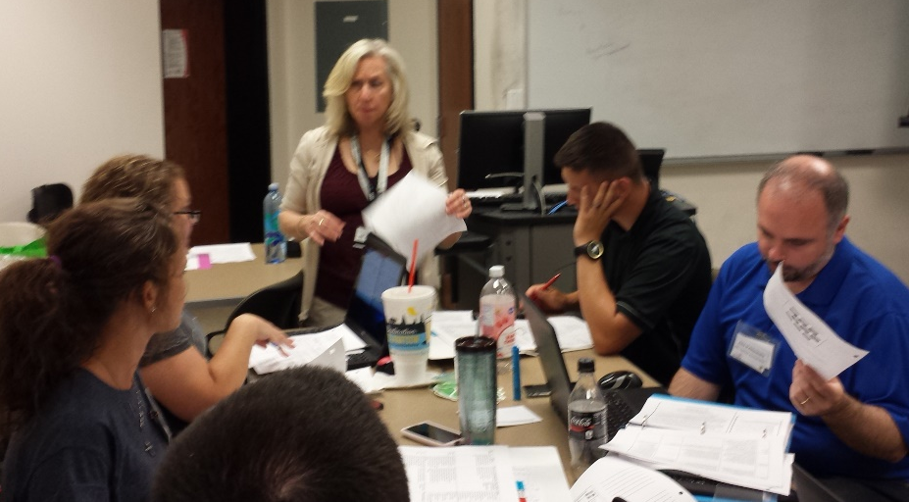
FIGURE 3: Mrs. Liberi Discussing Assessment Ideas in Class

The question was asked: What kinds of formative and summative assessments are embedded in the EDP process? Teachers discussed at their tables some assessments that had been considered. Some of the ideas from the teachers were to use a flow chart and have students take a known substance through it, as a control, to see if the control arrives at the correct conclusion. Another idea was to test samples of green verses non-green products, then use acetone as a control. Use their process to create an advertisement that had a rubric. Take a known substance and test it through the flow chart. Do this with everyone’s flow chart to see how it comes out. Test things to see if they will pass thorough the flow chart. Give students samples of green verses non-green products to see if they come up with the testing. Maybe there is a step in which they must imbed everything in the flow chart.

Guiding questions were discussed. Teachers were asked to name some guiding questions. Guiding questions are very specific questions about what learning needs to take place. Guiding questions are more related to how they will understand the challenge. These are the questions that must be answered before the challenge begins and they address what they need to know in order to do the challenge. Each challenge and activity will have its own set of questions that pertain to the information being taught.
Some examples include: Challenge: The difference between a green product and a non-green product. Guiding Question: How do you measure pH, difference between acid and a base?

Figure 4: Online assessment discussion
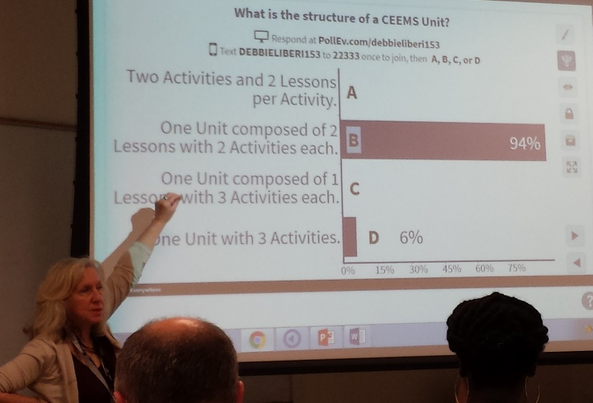

What kinds of formative and summative assessments are used? Teachers were asked to discuss at their table; some assessments that you had considered. Flow chart assessments are used to determine where you should start with your assessment. Use their process to create an advertisement that has a rubric. Take a known substance, bring it through the flow chart. Do this with everyone’s flow chart to see how it comes out. Test things to see if they will pass through the flow chart. For example, give students samples of green verses non-green products to see if they come up with the testing. Maybe there is a step in which they must imbed everything in the flow chart.

At the end of the session, teachers took an online poll, using PollEverything, as a post assessment. Each question was discussed before being dismissed.

The second session on templates started July 27, 2016 in Zimmer hall room 414.
The session began with Mrs. Liberi handing out a pre-assessment for the workshop. First, Sam Mizener gave an introduction for Mrs. Liberi. Objectives were written on a power point for post unit implementation. Teachers were asked to get out there binder with their post implementation information on it. Pre-assessment quiz was taken with pairs optional. The pre-assessment focused on post implementation templates.
Mrs. Liberi reviewed the pre-assessment with the class. Purple and green are the colors used in the text. Purple is beforehand and green text is afterwards. The sections that are reviewed after are the EDP section, misconceptions, pre and post implementation and activities. After everything has been revised, Teachers must work on their poster, videos, evidence of growth in student learning and reflection.
Video must be planned. Teachers were reminded to take video throughout the process. The evidence of student growth will be the pretest weighed against the post-test. The reflection has questions in binders to help teachers write their reflections. Reminders are to get testimonials from students and work with your RET team resource teacher.
Part 2 on templates is about evidence of student growth. Charts and graphs are used to show representations of student growth. Teachers should also write about the graphs and data. Reflections should be started with the end in mind. Some questions to think about:

Did you meet your mark?
Did the students learn the content?
What does the data indicate about growth and student learning?
What would you change if you retaught the unit?
Would you teach this unit again? Why or why not?

The check list is a tool to guide the process. Teachers were asked to think, pair and share the checklist. Teachers were asked about the check list. Some of the observations from other experienced teaches were that it is important to revisit the checklist. Placement of the check list is important, such as physically placing it next to the monitor. The check list can be placed in calendar applications.
The final word was to get things done right away and not to wait until the last moment.

